**Aim**

To perform preorder, inorder, and postorder traversal of a binary tree.

**Traversal Definitions**

* **Preorder:** Visit root → Traverse left → Traverse right
* **Inorder:** Traverse left → Visit root → Traverse right
* **Postorder:** Traverse left → Traverse right → Visit root

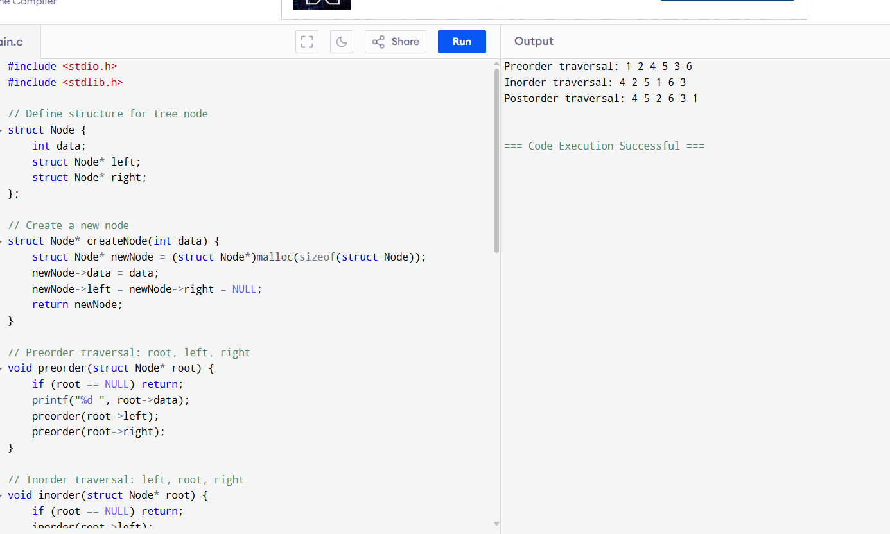

**Sample Output**

Preorder traversal: 1 2 4 5 3 6

Inorder traversal: 4 2 5 1 6 3

Postorder traversal: 4 5 2 6 3 1